
AMERICAN INTERNATIONAL UNIVERSITY-BANGLADESH (AIUB)
Department of CSE
Computer-Aided Design and Drafting

Section: L
Experiment No: # 05
Name: Khan, Md. Sazzad
Id: 22–49172-3
Supervised by: MD. RAKIBUL ISLAM CHOWDHURY

Name of Experiment: Introducing Electrical Symbols used for Electrical Circuit Design and drawing some Electrical Circuits using AutoCAD.

AutoCAD Comments:

- How To Create a Block in AutoCAD:

Block >> Enter >> input name >> Select objects >> Enter
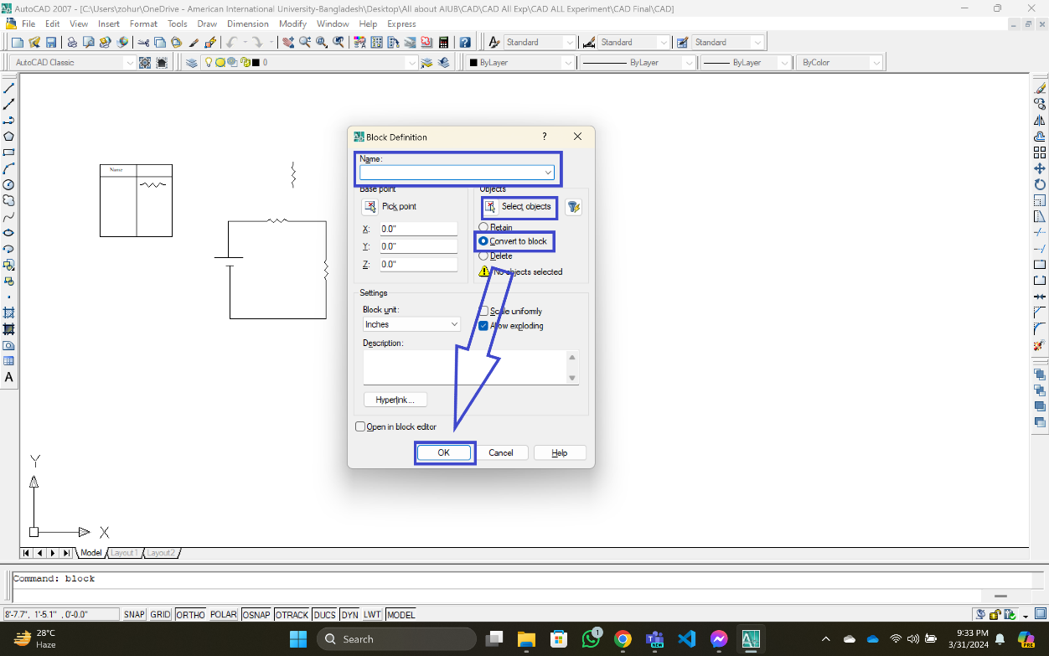
- How To Hatch in AutoCAD:

Hatch >> Enter >> Type: Predefined >> Pattern: SOLID >>
Swatch: ByLayer >> Add: Pick points >> Select Boundary >> ok

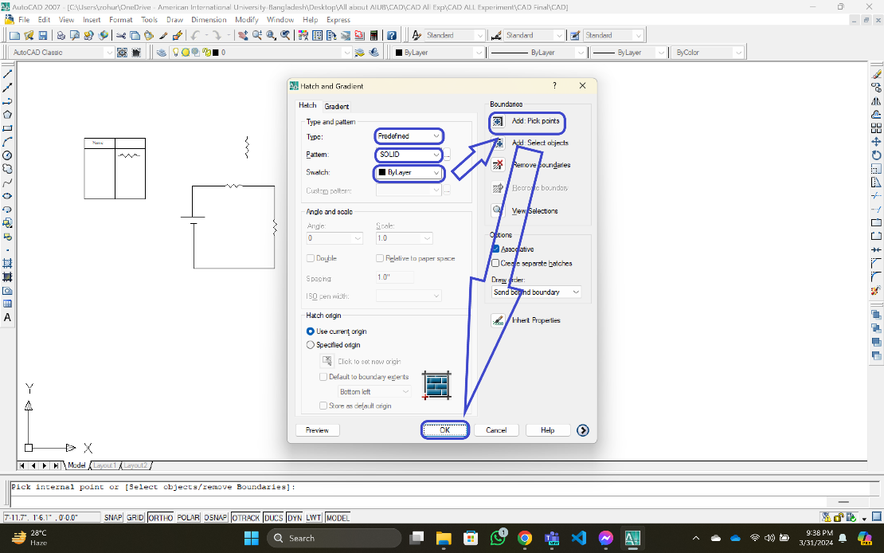

- How To Osnap Settings in AutoCAD:

Osnap >> Enter >> Select All >> ok.

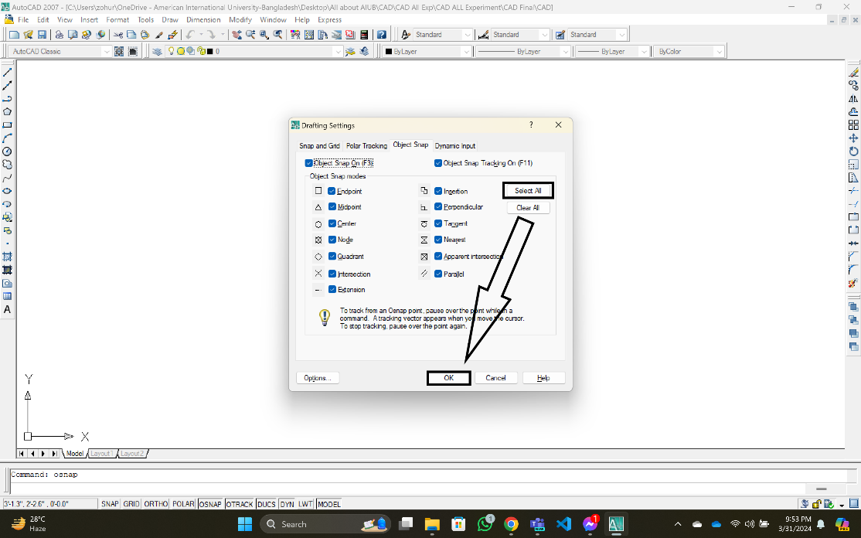

- How to Increase the Size of a Group Objects:

Scale >> Enter >> Select Object >> Specify Base point >> Enter the
Multiplier >> Enter.

- How to Rotate:

Rotate >> Enter >> Select object >> Specify Base point >> input Angle >>
Enter.

- How to Extend Line:

Ex >> enter >> Enter.

